**Chapter 1- Knowing the client and suitability**

1. **Building relationships**

For the client the benefits of long-tem relationships include:

* Convenience- no need to research insurance products/services
* Confidence- most SMEs do not employ risk mgmt professionals so owners rely heavily on the guidance provided by the insurance adviser
* Bespoke/tailored professional advice
* Ensuring value for money- if the adviser has an in-depth knowledge of a client’s business and their attitudes/preferences, they can tailor the insurance solution.

Long-term relationships also benefit adviser:

* Extra business opportunities- for intermediaries in particular
* Better retention rates
* Fast and efficient problem-solving
* Client industry insight

1. **Gathering information**

B1- Considering the clients wants and needs

The client will bring certain wants to adviser, analysing these wants is not always straightforward; it is important to look beneath the surface to identify their exact nature. Only then can the adviser make an informed assessment as to whether those wants are achievable.

B2- Considering the client’s attitude to risk

The client’s appetite for risk will influence their insurance needs and how much importance they give to them. No person or business is comfortable carrying every risk themselves, because:

* Unknown future costs are not always easy to meet from available resources (severity)
* No way of knowing how often risk will become a real event (frequency)
* The apparent likelihood of risk may be completely different to mathematical likelihood (frequency)
* Ultimately some risks, no matter how unlikely they seem to be, are potentially too costly to meet from available resources (severity)

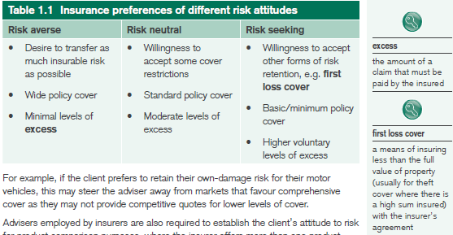

B3- What information do we need from the client

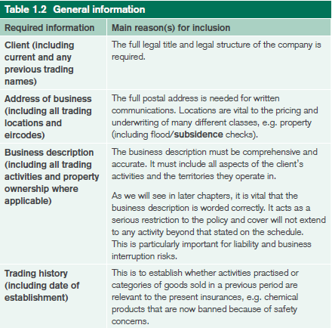

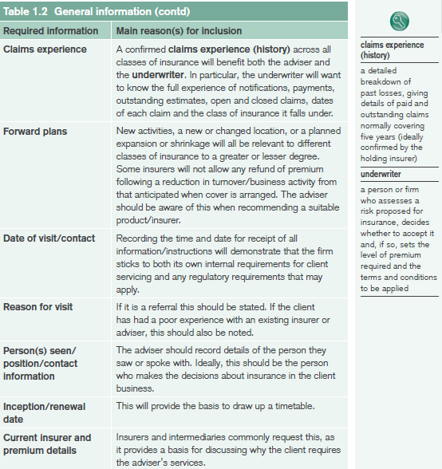

1. **Presenting information to insurers**

When presenting the risk to insurers, the adviser should pay special attention to the following:

* Comprehensive business description- this is especially relevant to business interruption and liability covers. Adviser should also look out for any planned changes to the clients business activities
* Details and analysis of claims experience (history)- the adviser should give explanations of significant losses and details of any steps taken to stop the loss from occurring again
* Risk mgmt and safety statements- insurers need to know how businesses assess and manage their risks. Safety statement- a legally required doc that describes the mgmt of health, safety and welfare responsibilities of the org.

1. **Considering insurers and insurance products**

D1- Price

Often the most obvious factor for deciding between products and the client’s primary concern. The adviser must ensure that he client considers all the relevant factors before deciding.

D2- Levels of service (including claims service)

Advisers ill look for:

* A dedicated relationship manager/executive to build a strong partnership with
* Fast and efficient quotations and accurate documentation
* Easy access to underwriters/decision-makers
* Competent survey system that is speedy and efficient
* Efficient claims handling and prompt payment of claims
* Fair and quick approaches to complaint resolution
* Availability of credit facilities or flexible payment options

D3- Breadth of cover

Adviser will normally seek the widest possible cover. It is therefore important to understand the variations between different insurers’ policy wordings, so accurate comparisons can be made. Cover comparison charts are a means of visually displaying the key differences between the characteristics of different insurer’ policies.

D4-Insurer’s capacity

Is the insurer’s ability to accept risk or meet future request for increases in cover. All insurers have limits to the maximum size of risks they can accept.

D5- Insurer’s experience

Certain insurers will gain a reputation in the mrkt for their expertise in relation to particular types of risk- taxis, construction etc.

D6- Continuity

The adviser should recommend continuity with a clients existing insurer where this seems the most appropriate way forward.

D7- Advisers experience and judgement

An adviser’s ability to exercise sound judgement relies on a no of factors; their knowledge of the mrkt, their familiarity with different insurer’s approaches to types of risk.

1. **Presenting the recommendation to the client**

Principles governing this statement of suitability are as follows:

* The adviser must offer the most suitable option available. For intermediaries, this will either be a based on either a fair analysis of the mrkt or a limited analysis of the mrkt
* The adviser must offer a product that meets more of the client’s needs than any other product, they can offer their professional opinion
* If there are genuine reasons for offering options than recommending a single product, the adviser must highlight all relevant differences in cover levels, T&Cs to allow the client make an informed decision

**Chapter 2- Commercial motor insurances**

1. **The compulsory nature of motor insurances**

Motor insurance is the only complete class of insurance business that is compulsory by law in Ireland

1. **The scope of cover**

Policies are subject to limits of indemnity (financial limit imposed by an insurer, representing max amt it will pay in any one claim). No limits apply to 3rd party injuries. The standard property indemnity for a private car is €30m and €1.3m for a commercial vehicle. Premiums are based on several exposure measures (an actual or proxy measure or risk as appropriate to the type of insurance, including (for single-vehicles policies:

* Vehicle- make model, year, carrying capacity and value
* Business description
* Driver details- inc penalty points/convictions, licence type, health issues etc
* Location of use
* Cover required
* Use of vehicles- specific use- such as agriculture use, taxis, business use
* Past claims experience

In the case of fleet-related, the most important factor is past claims experience.

Similar to private motor insurance, there are 4 levels of cover for commercial vehicles:

* Road Traffic Act Cover- min level if cover required by law
* 3rd party only
* 3rd party fire and theft
* Comprehensive

B1- Road Traffic Act

It is usually only provided when the claims experience is very poor or driver has past driving convictions. Cover applies in Ireland and EU and must provide indemnity for:

* Bodily injury or death, caused to 3rd parties inc passengers (unlimited in amt)
* Loss of, or damage to, property belonging to 3rd parties, subject to min of €1.22 m/claim
* 3rd party claimant costs and other expenses of handling a claim
* Emergency treatment for 3rd parties caused by, or arising out of RTA liability
* Liability arising from trailers attached to, or becoming detached from vehicle insured under the policy

Cover is restricted to the use of vehicle ‘in a public place’

B2- Third party only cover

* Anyone driving or ‘using’ the vehicle with permission (if allowed on the Certificate of Motor Insurance)
* The insured’s employer or partner (if their use is covered by the policy)
* Persons getting into or out of the vehicle
* The person in charge of the vehicle
* The hirer of the vehicle (for negligence by the PH)
* Or their personal representatives (if the person is deceased)

TPO also covers:

* 3rd P emergency treatment where required by law
* Liability arising from loading/unloading the vehicle
* Increased limit of indemnity for 3rd P property damage- typically €1.3m for any 1 accident, but with higher options available
* Legal representation to defend a charge- subject to limit- typically €1,000 - €10,000
* Use of unlicensed drivers where a licence is not required by law and the person is only enough to drive

Exclusions:

* Any loss or damage to the insured vehicle or the insured’s property
* Use other than for business activities of the PH
* Driving of other vehicles

B3- Third party fire and theft cover

In addition to the cover under TPO, TPF&T also provides cover for:

* By fire (including self ignition), lightning or explosion
* During an attempted theft or while it is stolen
* If stolen but not recovered

In addition to typical exclusions, this cover typically excludes:

* Driving of other vehicles
* Breakage of glass in windscreens and windows

B4- Comprehensive cover

As well as the above, COMP cover includes accidental loss, or damage to the insured’s own vehicle, other than as a result of theft or fire and also includes:

* Spare parts and accessories kept in, or on the vehicle
* Radio subject to limit (e.g. €750)
* Breakage of glass in windscreens or windows. May be subject to a limit and possible an excess, but does not affect the NCD
* Indemnity to principals where required

Cover typically excludes:

* Depreciation, wear and tear
* Mechanical/electrical fault or breakdown/derangement
* Isolated damage to tyres
* Theft/attempted theft, where the vehicle is unlocked
* Loss of use, e.g. the cost of hiring a replacement vehicle
* Import costs outside the EU
* Damage caused by solidifying of substances. These vehicles must be regularly maintained and working practices must be enforced to prevent solidifying of contents

B5- Territorial limits

Territorial limits for full policy cover apply within Ireland, NI, GB, IoM and Channel Islands. Policies automatically provide min cover required by law for territories with the EEA.

B6- Optional benefits

Optional benefits include:

* Trailers- although policies provide TPC to this, cover may extend to cover damage to specified/unspecified or attached/unattached trailers
* TP working risk (tools of trade)- covers situations where a vehicle is being used off-road (crane/cheery picker). This may already be covered under a public liability policy, so adviser should make sure cover only applies to one policy
* Fatal accident benefit- provides a personal accident death benefit for the driver only
* NCD discount or step-back option
* Cover for incorrect fuel type or lubricant- damage cause to engine is not covered- only draining the engine

B7 Policy conditions and exclusions

B7a- General Policy conditions

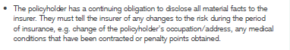

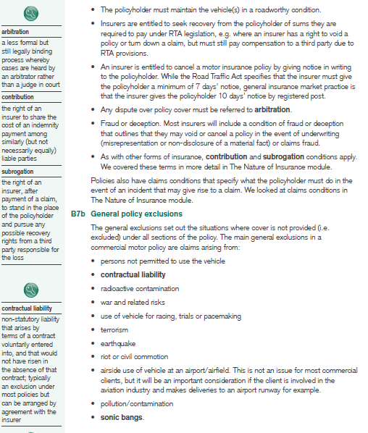

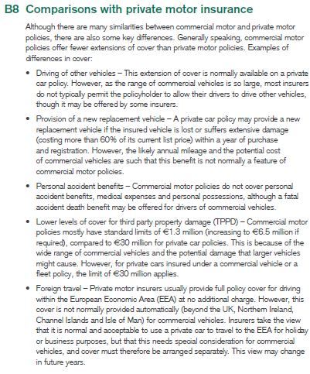

1. **Considerations for different types of commercial vehicle**

C1- Goods-carrying vehicle

This type forms the largest group of commercial vehicles and varies from small vans to articulate vehicles, tankers and refrigeration vehicles. The limit of indemnity for damage for TP property is €1.3m for smaller vehicles, rising to €2.6m for HGV.

C1a- Trailers

Trailers are a significant asset and the question of insuring them is not solely based on the min legal requirement. The cover can be summarised as follows:

* 3rd party attached trailer cover- standard cover is for 3rd party liability while drawing trailers that are directly attached to the insured vehicle. Covers 3rd part injury/damage caused by the trailer, but not damage to the trailer itself
* 3rd party unattached trailer cover- this extension covers 3rd party liability arising from an unattached trailer. If the trailer/s are specified (individually listed) on the policy schedule, each must carry an ID number
* Specified trailer un/attached full policy cover- this extends the full policy cover (fire, theft or comp) to all trailers that are individually listed on the schedule. Full details of the trailers, inc values and ID numbers must be provided to the insurer

C2- Passenger-carrying vehicles

Two categories of vehicles- public service vehicles and self-drive hire and funeral vehicles.

C2a- Public Service Vehicles (PSV)

A PSV is defined as a mechanically propelled vehicle used for the carriage of persons for reward. PSVs are divided into:

* Large PSVs- seating accommodation for more than 8 people inc the driver and are usually, buses, coaches and minibuses.
* Small PSVs- seating accommodation for a max of 8 inc driver and include:
  + Public hire vehicles- they have a taxi meter and roof sign are for hire at an appointed taxi stand, by driving around waiting hire by radio contact or in a designated taxi-meter area
  + Private hire vehicles- hackney cares that are used for hire or reward by prior arrangement only

The high level of use of PSVs represents a significant risk of accident, while they are passenger-carrying means the claim can also be potentially very costly (severity)

For large PSVs, own-damage cover can carry very high excesses due to the very high cost of the vehicles e.g. up to 200k for a new bus/coach

C2b- Self-drive hire and funeral vehicles

Self-hire includes cars, small vans, and campervans hired out to public. The hirer usually completes an application for insurance and there may be limits of acceptance depending on occupation, driving record and length of time insurer has a full licence. Typical permitted use is for social, domestic and pleasure and exclude use for carriage of persons for reward.

Funeral vehicles are considered lower risk as they operate in a local radius at low speed and have very low mileage. Repair costs can be high as with any specially built vehicle.

C3- Special-type vehicles

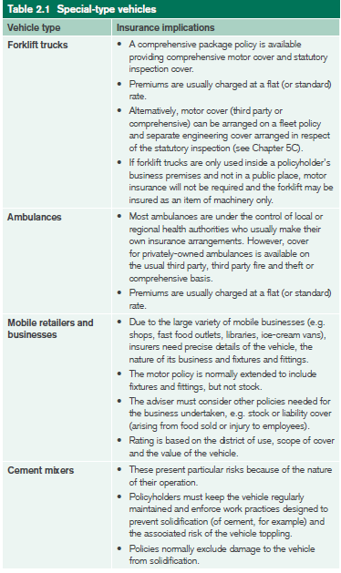

C4- Construction equipment

As theft is a particular issue, some insurers may exclude this altogether while others may insist on security measures such as anti theft devices or immobilisers. Main categories of this include

* Cranes- for all cranes, engineering covers must be arranged and statutory periodic inspections and certification are required. For mobile cranes RTA cover is required.
* Dumpers- the key rating factors are the vehicle’s use and carrying capacity, so it is important to establish exactly what it is being used for and to determine if it is being used exclusively on the PHs premises or in a public place
* Mechanical navvies and other mobile plant equipment- this also includes shovels, grabs and excavators. In addition to hire cover, policies also cover damage while in use as a tool of the trade
* Other ‘special types’- including road rollers, site-clearing and levelling equipment, sludge gulpers, tippers and trolleys none of which are for general transport on road.

C5- Agricultural vehicles

Includes harvesters, tractors and other motor vehicles as well as implements and trailers. There are some differences to other commercial vehicle policies, including:

C5a- Suspension of cover

Some vehicles are only used for a short period of time i.e. combine harvester, soothe premium automatically takes into account the seasonal use of some agricultural vehicles. Motor insurers do not therefore give a premium refund for suspension of cover, as they already allow for this during the rating process

C5b- Crop spraying

C5c- Hiring practices

Framers often help each other and hire equipment to and from. If this is the clients practice, the adviser should make the insurer aware of this and provide full info regarding the use. Insurers normally provide indemnity under the agricultural motor vehicle policy to anyone who has hired a vehicle and the driver.

Insurers may also be asked to extend cover while a vehicle is hired or let to public authorities e.g. hedge cutting or snow clearing. Indemnity to hirer is subject to usual provisos- no other policy can provide indemnity.

C5d- Use warranty

The ‘use warranty’ appears in the policy schedule and will reflect the agreed use when the policy was arranged. It may be limited to farmers own land or neighbouring farmers land or unlimited.

C5e- Road-worthiness testing for ‘fast tractors’

In Ireland, agricultural vehicles are not currently subject to road-worthiness testing. However, a 2014 EU directive introduced the compulsory testing of tractors used for commercial road haulage purposes with a max designed speed exceeding 40km/hr (‘fast tractors’). They must display certificates of roadworthiness.

1. **Motor trade insurances**

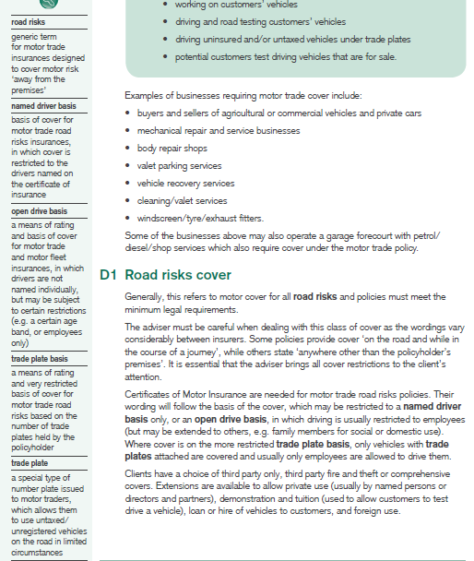

D2- Internal risks policies

Motor trade liability cover specifically for premises risk (including servicing and maintenance)

Cover includes the insured’s liability for:

* Accidental injury or death to 3rd party (other than employee)
* Accidental damage to a 3rd parties property
* Injury and damage arising from the sale of new/used vehicles, as well as parts and accessories
* Injury/damage caused by defective workmanship in a vehicle, e.g. a mechanic does not tighten a wheel-nut properly

D3- Combined road and garage policy

Combined policy is a type of policy that groups together a no of separately underwritten covers in 1 contract

1. **Motor fleet insurance**

These policies differ from standard policies in the following ways:

* PH has more flexibility when changing vehicles and/or drivers
* Premiums for larger fleet-rated risks are based on claims experience of the fleet, rather than on the insurer’s normal rating system
* Certain optional covers may be added for an extra premium
* For smaller fleets, the NCD for each individual vehicle is replaced by fleet discount. This discount is applied to the insurer’s normal commercial vehicle rates

E1- cover arrangements

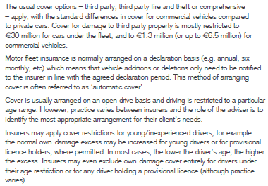

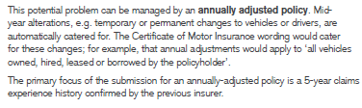

E2- Extensions of cover

E2a- Contingent third party cover (employees’ vehicles)

Extension on a motor fleet policy to protect a PH when their employee is using their own vehicle for business purposes. In these situations the employee needs to ensure that their private motor policy includes cover for business. Contingent TP cover provides some protection to a commercial client if for any reason the employees policy is defective i.e. forgets to renew, not covered for business use or they fail to disclose material facts.

E2b- Occasional business use

This indemnifies a commercial client whose employees sometimes use their own car on their employer’s business. It is not contingent cover and it protects both the client and the emp. Cover may specify a set number of business trips per month/year, or est mileage. Cover may be COMP, TPFT or TP only.

E2c- Driving by unlicensed drivers

This is an extension to cover a PH when no license is required for the driver by law or where the driver’s license status is unknown e.g. forklift in the boundaries of warehouse- ‘not a public place’

1. **Light commercial vehicles (LCV)**

An LCV is a vehicle designed and constructed for the carriage of goods and having a gross vehicle weight less than 3500kgs. The GVW includes vehicles chassis, body, engine, engine fluids, fuel, accessories, drive/passengers and cargo, but not trailers.

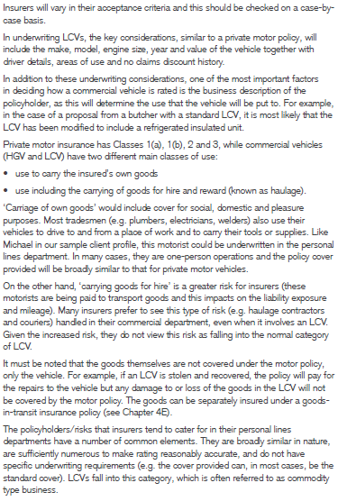

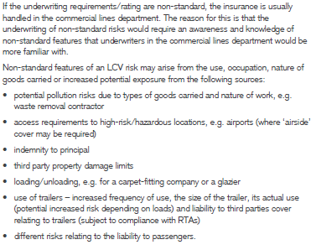

1. **Questions to ask the client**

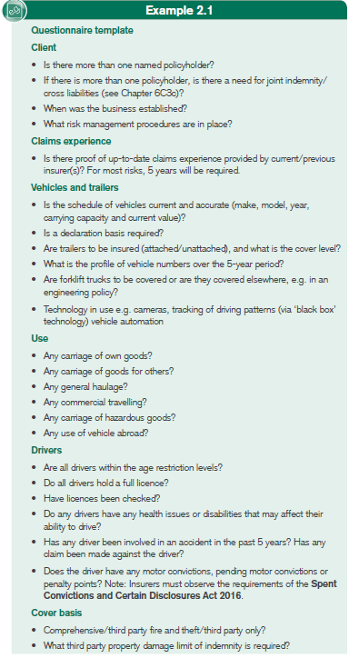

**Chapter 3- Commercial property insurances- insurable values & presentation of info**

1. **Arranging commercial property insurances**

For a commercial combined policy, the proposer complete 1 proposal form, where they indicate the covers required. Each cover is rated separately and the final premium is a total of the individual premiums.

For a commercial package policy, covers are not rated individually and the policy typically offers pre-determined sums insured and limits of liability. Policies usually include property, business interruption and liability covers. These policies are typically marketed to SME’s e.g. shops, offices etc. As these do not pose any unusual risk features.

1. **Establishing the sum insured**

B1- Buildings

The term buildings include:

* Landlords’ fixtures and fittings
* Outbuildings, walls. gates & fences, yards, car parks, roads and pavements
* Piping, ducting & cables (where they are the PHs responsibility)
* Landscaping

B1a- Setting a sun insured for buildings

The basis for setting sums insured is normally ‘reinstatement’. This means establishing the cost of rebuilding or replacing property lost, destroyed or damaged, to a condition equal, or mostly the same as its condition when new. Client needs to remember it is the cost of rebuilding and not the premises. It is advised that the client engage a professional property valuer to establish the cost to avoid under insurance. There are several ways that policy wordings can help clients set and maintain adequate sums insured:

* Reinstatement memorandum- in the event of a partial loss, the RM requires that insurers do not make a deduction for underinsurance if the sum insured represents at least 85% or the reinstatement cost at the time of reinstatement
* Day one reinstatement- a means of countering the effects of high inflation by providing an automatic increase in the sum insured based on accurate reinstatement sum insured on the first day of cover
* Index linking- a method of calculating the sum insured on buildings and contents that is adjusted monthly in line with appropriate indices, but in times of very low inflation may be set at ‘nil’

B1b- Additional cost

The following additional costs need to be included when establishing a buildings sum insured:

* Professional fees- architect, surveyor and consultant fees for rebuilding. When calculating these a suitable % uplift (usually 15%) should be added and the policy will normally include a pro fees clause confirming they are covered.
* Debris removal costs- a policy clause will normally confirm that the buildings sum insured is inclusive of debris removal costs. These must therefore be included in the calculations
* Public authorities’ clause- this is part of the standard policy wording and it provides for any additional costs incurred in complying with PA or bye-law requirements

B2- Contents and stock

It is important to set correct sums insured for the other items covered under the policy:

* Machinery, plant fixtures, fittings and all other contents
* Tenants’ improvements, alterations and decorations
* Contents of outbuildings and contents in the open e.g. in a yard
* Personal effects- excluding motor vehicles- belonging to employees, directors, and visitors, if not otherwise insured
* Money, documents, manuscripts & computer system records, up to a limited amount

Stock includes both stock in trade and goods held in trust or on commission that the PH is responsible for.

B2a- Setting a sum insured for contents

For most policies, the sum insured for contents is on a reinstatement basis. Same options exist for buildings. The sum is usually expressed as a single figure. This is to the PHs advantage as it reduces the possibility of average applying in the event of a claim (this would happen if 1 area of contents is understated, even if the overall avg is adequate). Sometimes it is advisable to separate specific elements such as ‘office contents’- office building carries a much lower fire risk than a warehouse or factory unit.

For manufacturing risks, a key element is the replacement of any specialist machinery. If there is a delay in replacing this equipment the time delay might add to the overall cost, so a ‘day one’ cover might be appropriate.

Inner limits- specific max limits for defined items within an overall sum insured (generally relating to contents) examples include:

* Money and stamps
* Computer systems records (only the cost of materials/labour in replacing these, not the information
* Any one pattern, model, mould, plan or design (set)
* Personal effects of employees, directors and visitors (per person)

B2b- Setting a sum insured for stock

The stock sum insured should be based on the cost price to the PH, not the sale price and include delivery charges, packing materials and the cost of any work carried out by the insured. In the event of a loss, the insured is indemnified- placed in the same financial position as before.

Target stock- stock that is particularly attractive to thieves, usually due to its portability and value. Goods classified as target stocks include:

* High value and small in size- easy to transport
* Have a ready second-hand (or black) market
* From an easily disguised source or supplier
  + Computer parts, electronics & hand-held electrical equipment
  + Pharmaceuticals
  + Tobacco/cigarettes
  + Wines/spirits
  + Jewellery and precious metals

Stock declaration basis- a method of allowing a PH to establish a stock sum insured to allow for seasonal fluctuation

Stock debris removal- the process of clearing, removing and disposing of damaged stock from a business premises.

B2c- Floating arrangements

If the insured operates their business from a few different locations, cover for contents and stock may be provided on a floating basis. The insurer may agree to allow one overall contents stock sum insured between all locations listed on the policy schedule. At the inception of cover the insurers will ask for a breakdown of the content values of each location. They will then calculate an average rate, which applies to the overall contents sum insured, at the renewal they will ask for an update. Floating cover is usually applied to stock rather than contents.

B2d- First loss cover

First loss cover is more suitable for theft, as with floating arrangements, this is more common for stock than contents. E.g. a PH has stock valued at 1m but they may consider the max value of the stock that could be stolen at any one time is 100k. this might be because the stock is too large or heavy. For this reason, they might consider insuring their stock on a ‘first loss’ basis with a ‘first loss sum insured’ of €100k.

When requesting this cover, a client may expect a much lower premium. However, this is not always the case insurers will consider the estimated max loss- the max loss the insurer is likely to sustain as a result of a single incident (within probability). In first loss cover, there is very little practical reduction in the insurer’s likely exposure and the premium will take this into account.

1. **Questions to ask the client**

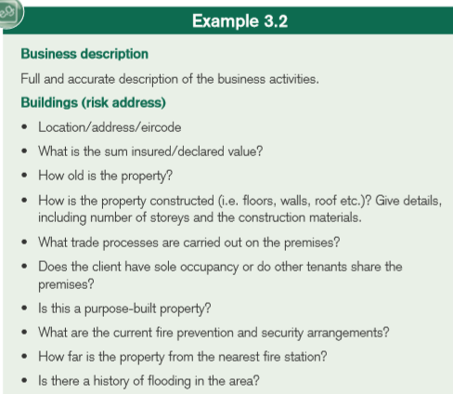

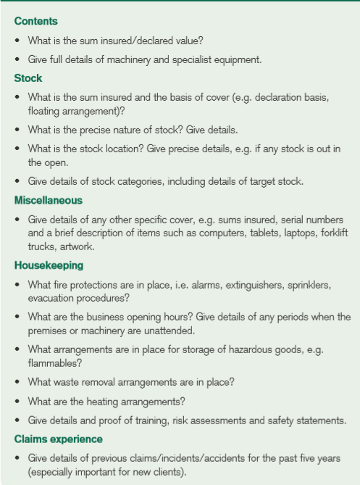

1. **Submitting a new commercial property risk to insurers**

D1- occupation/business description

It is important the adviser describes fully & accurately the occupation/business to the insurer. The business description is the starting point for developing the basis of rating. In the event of a claim the insurer will look closely at the business description, if the PH fails to disclose an element of business, then this may not be covered.

D2- Details of the property and the key risk

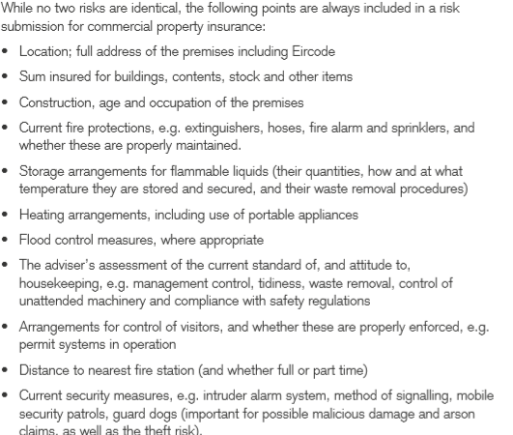

D3- Claims experience

An up-to-date claims experience with full details of previous claims and losses should be provided. The advisor should provide appropriate explanations, especially in relation to mitigating factors- factors an insurer might look on more favourably.

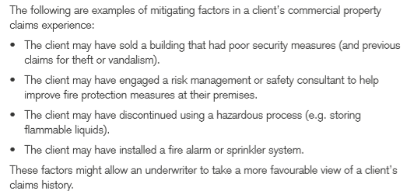

**Chapter 4- Commercial property insurances- policy cover**

1. **Property insurance**

A1- Fire and perils cover

A1a- Fire

For the purposes of I cover, the term ‘fire’ is define more by its exclusions than by its cause. Fire cover excludes some specific events such as:

* Explosion resulting from fire- this is a separate peril
* Earthquake or underground fire- separate perils
* Spontaneous fermentation/combustion- a fire that is cause by a process of self heating rather than an outside ignition
* Damage to property while it is undergoing any process involving the application of heat (welding). If the fire spreads to other insured property, then this will be covered by the policy

A1b- Lightning

Covers all damage/destruction caused by lightening

A1c- Explosion

Standard cover applies in respect of damage resulting from domestic boilers and gas appliances. Does not provide cover explosion of commercial boilers or steam pressure vessels. If this is required a separate engineering policy should be arranged.

A1d- Aircraft

Covers damage to property caused by an aircraft and by articles dropped from an aircraft.

A1e- Earthquake and underground fire

Earthquakes are very rare in Ireland so insurers normally include this cover automatically and at minimal cost. Underground/subterranean fires are not an issue in Ireland, cover as above.

A1f- Riot, civil commotion, and malicious damage

This cover is available under most commercial policies, special terms include:

* Riot- a public act of violence by an unruly mob
* Civil commotion- an uprising of a large no of people, usually resulting in damage to property
* Malicious damage- deliberate damage to, or destruction of , property by the wrongful act of any person

It can be difficult to distinguish between malicious damage and attempted theft, if there is damage but nothing stolen.

A1g- Storm & flood

Climate change has increased the frequency and severity of these perils. Some insurers are refusing to cover people in certain areas. A standard exclusion is damage to movable property in the open, and to fences and gates.

A1h- Escape of water

Refers to damage caused by the escape of water from any tank, apparatus or pipe. Cover is not provided to unoccupied buildings, due to the increased likelihood of burst pipes because building will not be heated.

A1i- Impact

This peril covers damage to the insured property as a result of impact by road vehicles or animals. Cover is usually provided for damage by the insured’s own vehicles/animals and 3rd parties V/A’s. This is particularly important for business with high traffic volume i.e. petrol stations, warehouses etc.

A1j- Sprinkler leakage

If one is in place, the adviser should ensure there is cover in place for this, as considerable damage can be done. During winter months, special precautions must be taken to eliminate/reduce the risk of water freezing and pipes bursting.

A1k- Terrorism

Standard policies exclude all forms of terrorism; however stand-alone policies can be purchased.

A1l- Subsidence, ground heave or landslip

Cover for these are often included within a material damage ‘all risks’ wording. For risks situated in known risk areas a separate Qst must be completed. It requests info such as; is the premises built on reclaimed land or an infill site? Are there any visible cracks in the walls?

A1m- Theft

Theft/attempted theft cover in a commercial policy is conditional on forcible and violent entry/exit from the building. A min standard of physical protection of property is required. Insurers may also require an alarm, especially if target stock is present. If an alarm is required, the policy will generally contain an alarm warranty, and cover will not operate unless the alarm is set when the premises is unoccupied.

The adviser should ensure that theft cover includes the actual buildings. There has been an increase in the theft of copper piping, tanks and lead flashings from roofs recently. Theft cover usually excludes any property in the open/outbuildings or theft in transit, as this is specifically insured under the goods in transit cover.

A1n- Accidental damage

This provides further cover beyond the cover provided by the various specified perils, such as accidentally dropping an item.

A2- ‘All risks’ cover

For cover to operate on the ‘fire & perils basis, the cause of the damage (peril) must be specifically stated in the policy. Under an ‘all risks’ policy, any damage is covered, as long it is not resulting from an excluded cause.

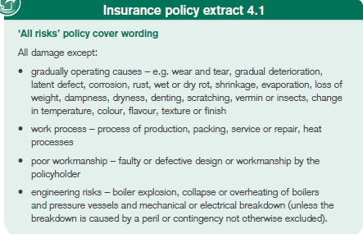

A3- Rent

Commercial property policies also include cover for loss of rent. This is the only cover under a material damage policy that relates to any kind of business interruption loss. The difference between the 2 is:

Under a material damage policy, loss of rent will be paid only if the insured buildings- or part of them- are unfit for occupation following insured damage. Cover only applies until the building is repaired/reinstated following a loss and is fit for occupation.

Business interruption policies cover a PHs loss of rent receivable. This cover extends until the building has actually been reoccupied.

A4- Extensions to cover

Some insurers provide ‘extensions’ as standard and others require a specific request to include them. A list of the most commonly requested are:

|  |  |  |
| --- | --- | --- |
| Services- full accidental damage cover for cables, pipes/drains | Trace & access- covering the cost of finding the source of damage- leak etc. Subject to limit e.g. €15k | Fire brigade charges- cover is subject to an automatic limit e.g. 6.5k or €10k |
| Damage by emergency services- damage to lawn, paths or garden | Landscaping damage | Replacement of locks |
| Workmen- this clause allows for minor work to be carried out without affecting I cover | Tenancy | Subrogation |

A4b- Contents

Temporary removal- the policy provides limited cover for contents that are away from the insured property for cleaning/repair. Cover applies within the geographical limits of the policy and is subject to a limit- e.g. €10k or 15% of sum insured.

Motor vehicles- for some risks, motor vehicles may be stored in the insured buildings. A very limited form of cover may be provided for damage to these vehicles while they are in the building e.g. as a result of a fire in the building.

A4c- Stock

Seasonal stock- a specific % uplift to sums insured on stock automatically provided by insurers for defined periods e.g. Christmas and Easter.

1. **Glass insurance**

This is usually an optional extension in a commercial property policy. Some policy wordings will apply a limit, whereas others will pay the ‘reasonable cost’ of replacing the glass without any specified limit. Typical exclusions include:

* Damage to glass in empty or disused property
* Scratching, gradual deterioration, wear and tear, change in colour or finish
* Damage to glass in light fittings

1. **Money insurance**

C1- Policy limits

Money policies have a few different limits, there are different limits in respect of cash and non-negotiable money i.e. credit-card sales, vouchers, cheques etc. Specific limits apply to:

Money on premises during business hours, in transit or in a bank night safe, this is a particularly important aspect of money cover. Insurers will impose strict conditions regarding the transit of money. A custodian warranty is a requirement by insurers that a certain number of able-bodied adults accompany money in transit (under a money insurance policy).

Money in locked safe- insurers normally cover cash in safes up to the safe manufacturer’s recommended limit. Keys or combination codes must not be kept on site.

Money in ATMs- insurers do not view these as being as secure as safes and will not wish to provide large limits for cash. There may also be a number of strict requirements and warranties regarding the loading of these machines.

Money out of safe overnight or at an employee’s house- a nominal limit of approx. 500.

Cover is on an ‘all-risks’ basis and the policy does not specify forcible and violent entry/exit. Although money policies usually exclude loss of money due to dishonesty of staff or directors, most policies provide some cover for losses that are discovered within 7 days. Losses after that period are covered under a fidelity guarantee policy.

1. **Computer insurance**

Regardless of policy, cover is generally on an ‘all risks’ basis. Cover for portable equipment is normally provided on a worldwide basis. Cover includes a provision for ‘increased cost of working’ (reasonable additional expenditure to avoid or diminish any reduction In turnover after loss) and ‘reinstatement of data’ (cover for the cost of reinstating data following loss or damage to comp equip, corruption of data and damage arising from electricity cut).

D1- Cyber insurance

Cyber insurance is cover that protects businesses and individual users from cyber risks, and more generally from risks relating to info tech infrastructure and activities.

1. **Goods in transit insurance**